FOR SALE
‘Aubin’ Moody 31 Mark II Fin Keel 1986. £24,000 for Private Sale.
Moored at Shotley Marina, Suffolk, England.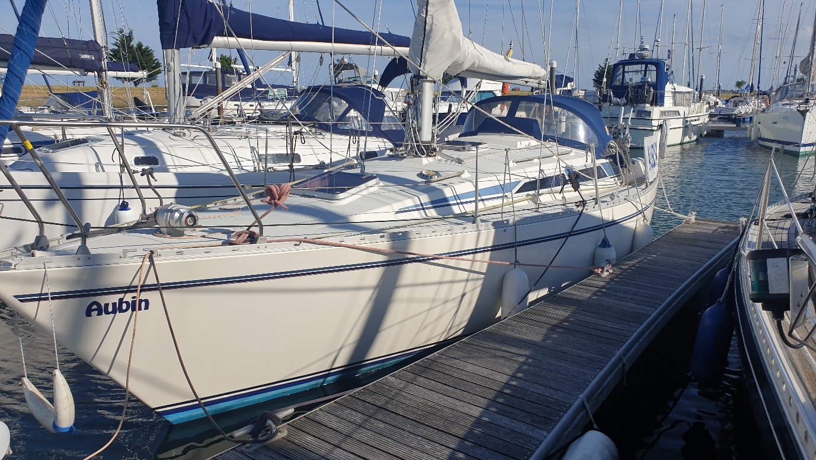

Aubin has been well maintained during current ownership since 2017 with several additions. She has cruised local and European waters and spent three years in the Netherlands between 2019 and 2022.
Running and standing rigging replaced in 2020
Engine Volvo Penta 2030 installed 2006. Shaft drive. New exhaust elbow 2024.
Fuel tank replaced 2019
Following inspection most keel bolts replaced 2019
Holding Tank with macerator installed 2019
Lines from mast including reefing running back to cockpit
Rotostay Furling gear for genoa with lines running aft
Windows in cockpit and main cabin recently replaced
Shore power with 3 sockets plus battery charger
International anti-foul over copper-coat. Hull and keel blasted in 2023. Keel epoxied. Note: Small osmosis blisters treated in 2023. Others may need treatment in next maintenance cycle. This is reflected in asking price.
Boat is ready to sail.
Contact: Alan Pawsey 44(0)7595 664790 alan_pawsey@btinternet.com

Inventory:
JRC 1800 Radar
B & G Vulcan 5 chart plotter with Navionics UK and W Europe
Standard Horizon Matrix VHF with AIS/GPS
Ram 3+ Command Mic to cockpit
Autohelm Wind and Depth; Nasa Log and GPS repeater above companionway. Compass on cockpit bulkhead.
Garmin GPS 128 at chart table.
Nav 4 Navtex Plus
Master Volt battery charger for two 12v batteries
Simrad TP22 tiller pilot
Spinlock tiller extension
LED Tricolour, steaming and deck lights (rewired and replaced 2023).
12v Fridge
Nelson Techna calor cooker. Two hobs, grill and oven
Refigerator
Lofrans Anchor Windlass
Seago 4 person life raft 2022
Rescue Me EDFI LED Flare
Sails:
Main – new in 2023. Suffolk Sails. Top two battens Rutgerson – battcar system.
Genoa – Very Good condition. UV strip replaced 2023.
Jib – Good Condition
Cruising Chute with snuffer
Various other safety equipment, warps and line
Inflatable Dinghy
2 CQR anchors, chain and warps
Fenders, step fender and docking fender.

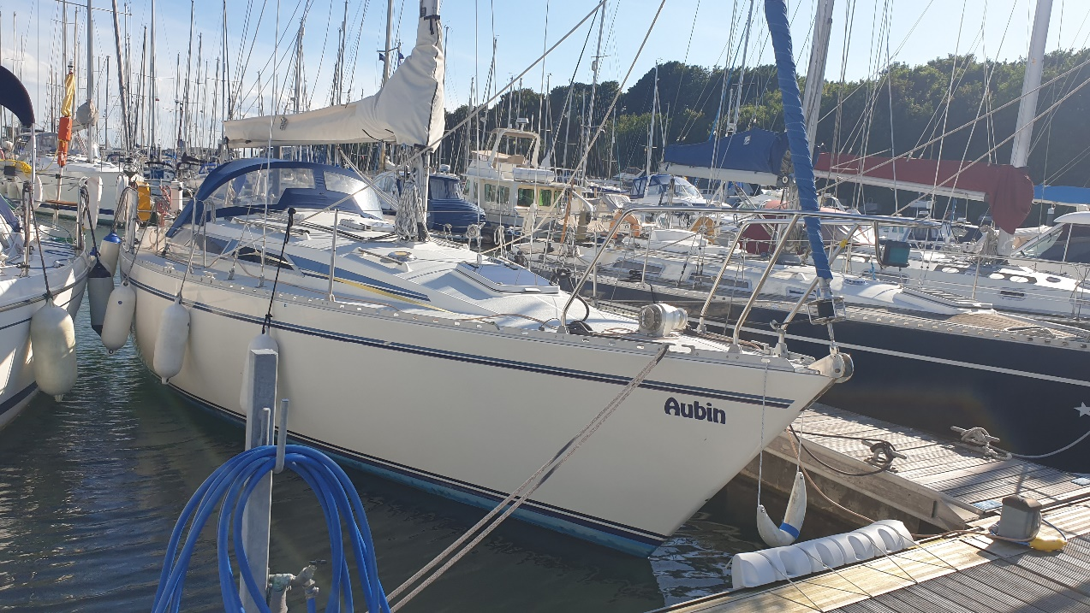

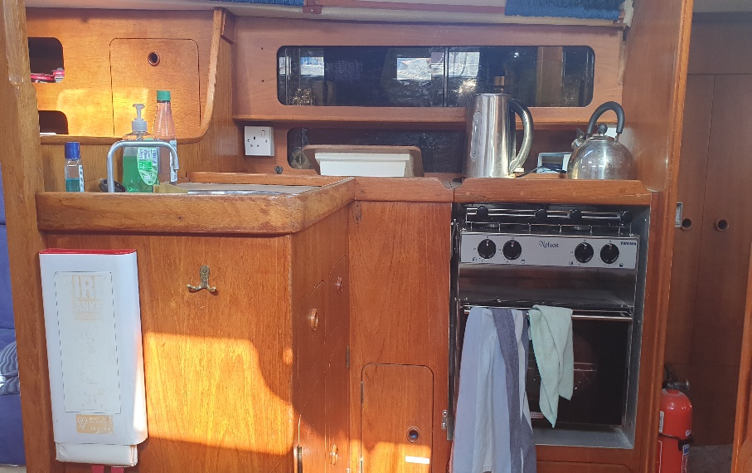

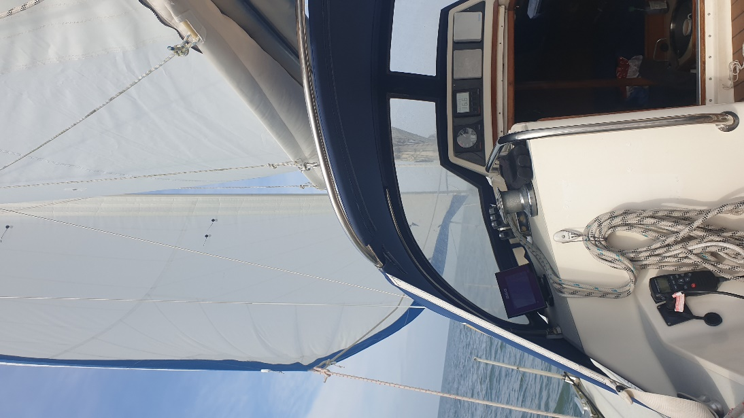
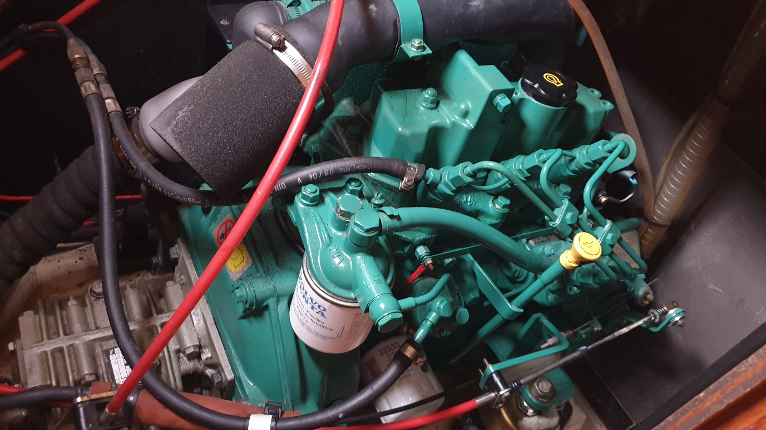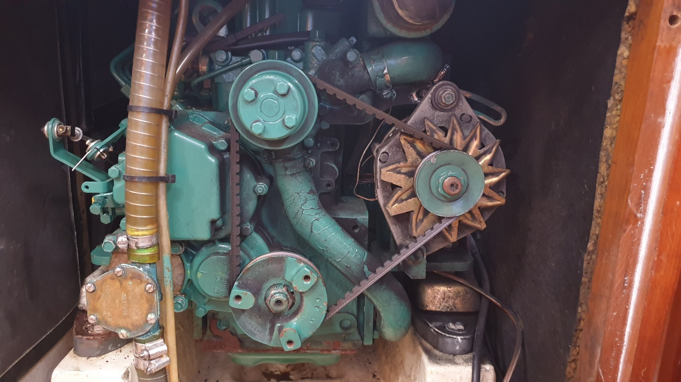
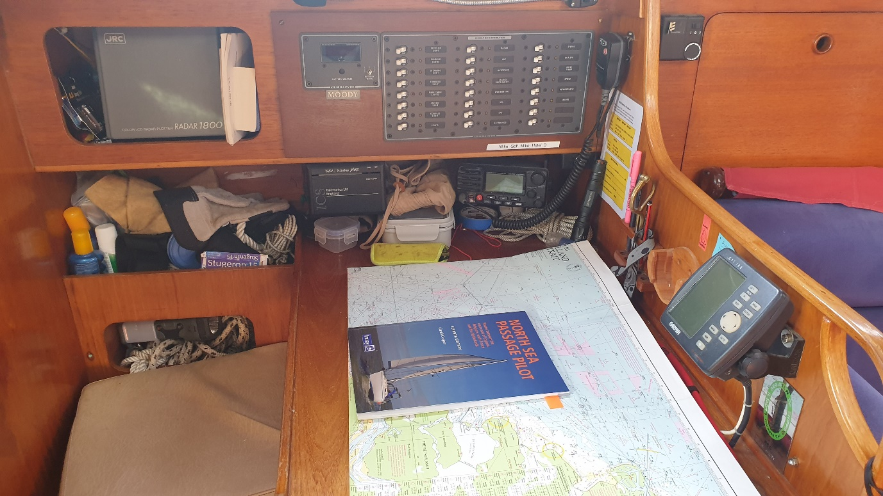

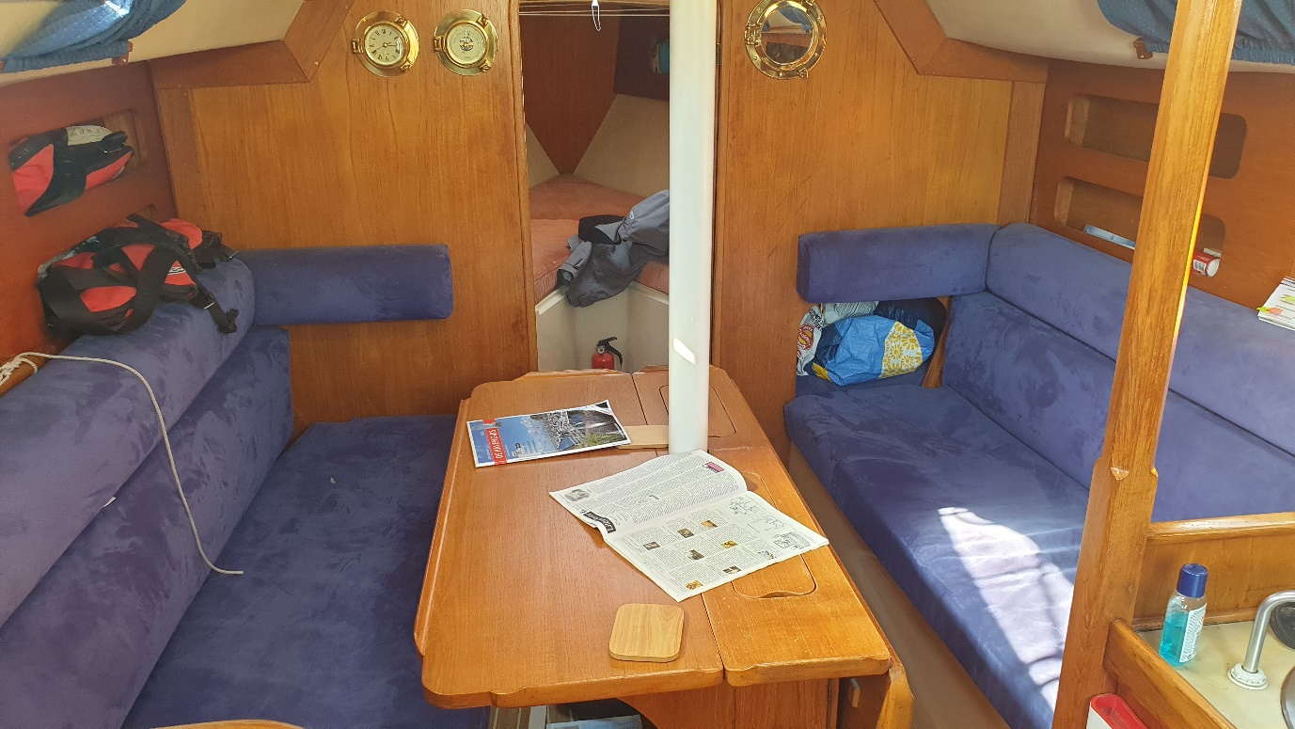

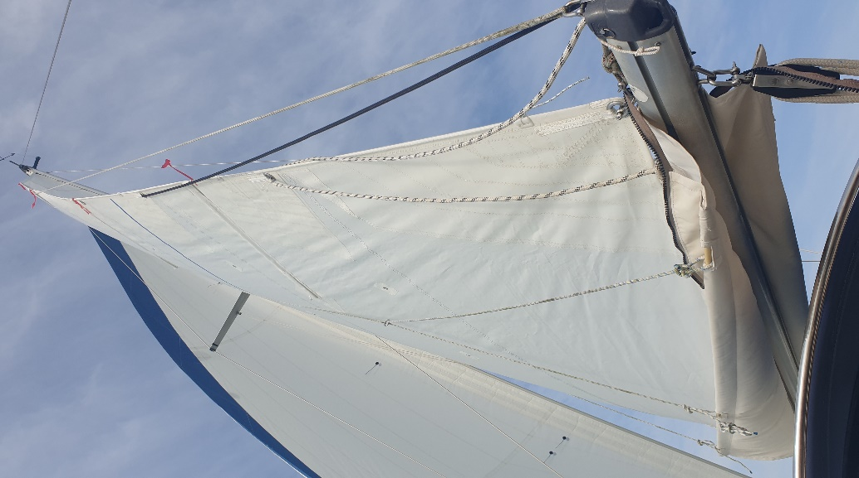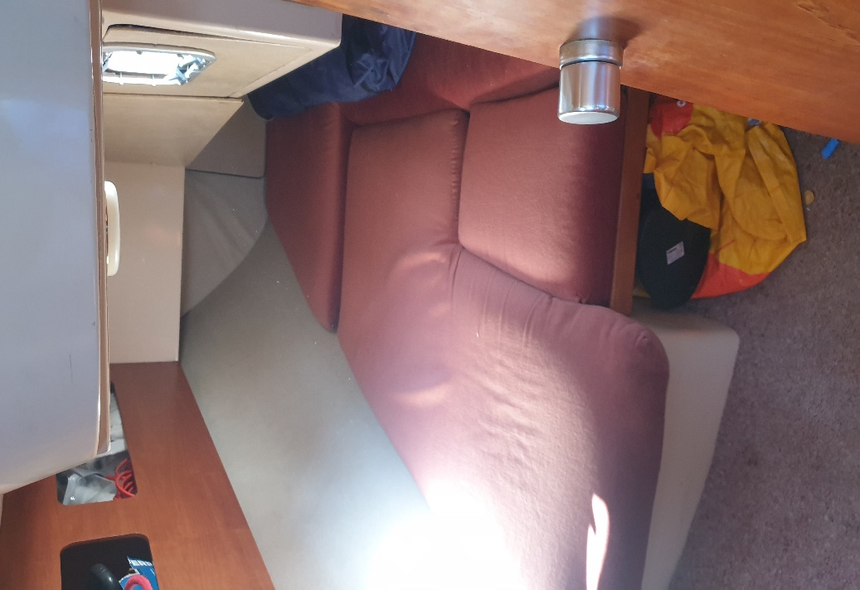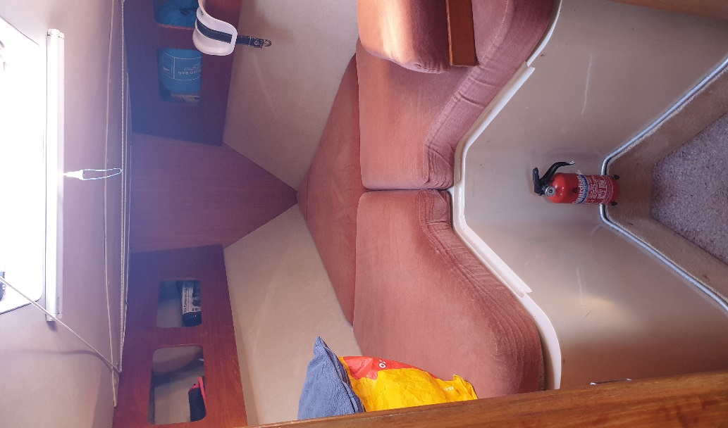

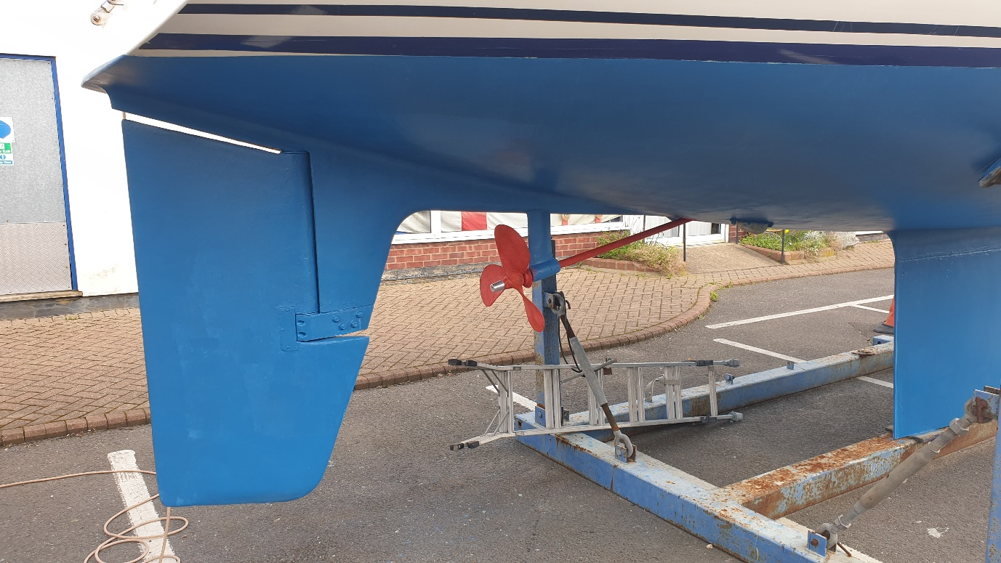
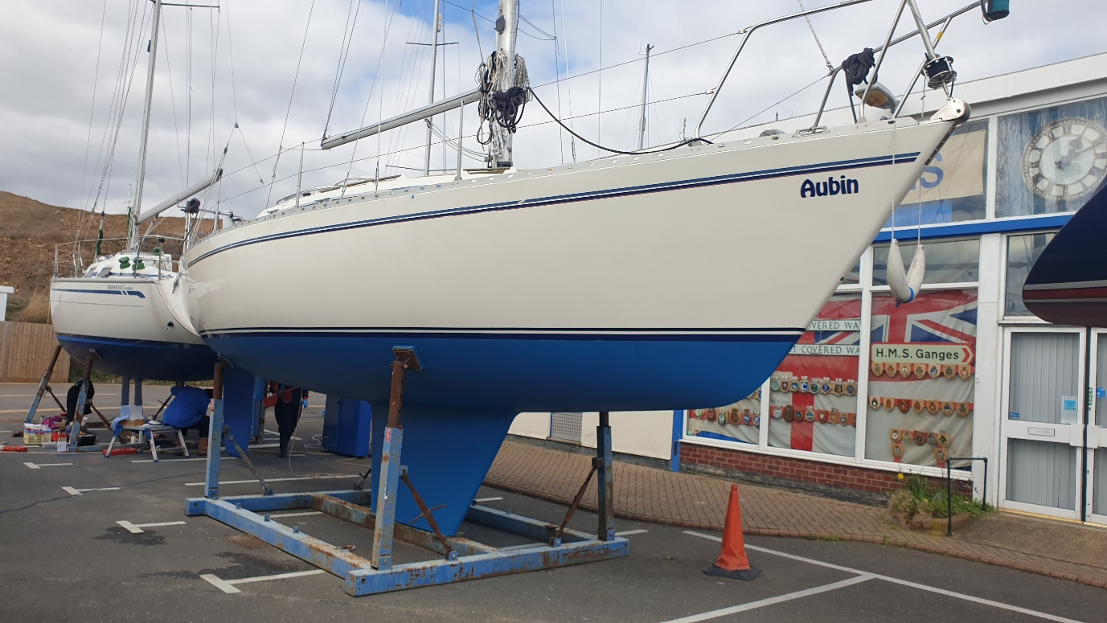
Maintenance 2023/4

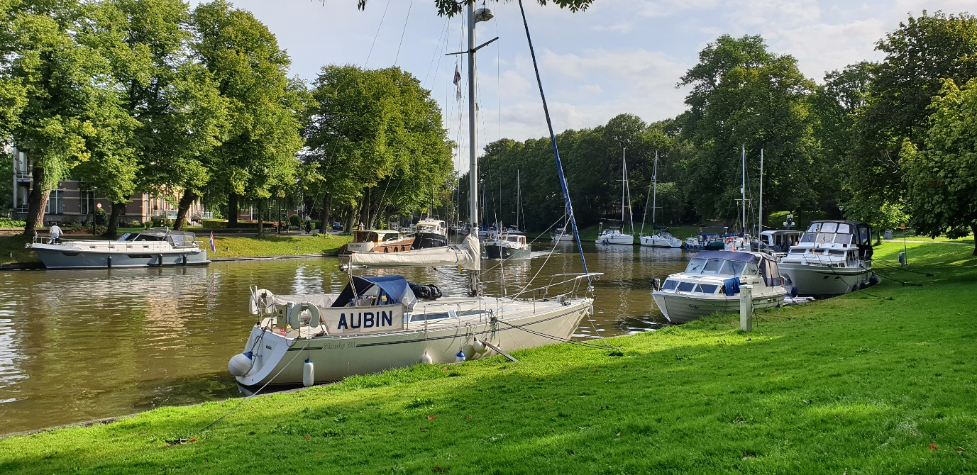
Leeuwarden 2019

