Moody 376 EPONA details

Standard details:
Year 1989
LOA 37’ 10” (11.53m) LWL 31’3” (9.53m) Beam 12’ 6” (3.81m) Draught 5’ 6” (1.68m)
Fuel capacity 204 litres Water capacity 250 litres
Engine: Thornycroft T80 – original engine, starts every time, no smoke and very reliable, serviced annually.
Sails & rigging
New standing rigging throughout in 2022
Main sail (Jeckels), new 2020. In mast furling
Genoa (Jeckles) new 2020. Furlex furling
Cruising chute in snuffler (Lucas Sails) Good condition
Spinnaker (Rarely used) Good condition
Storm jib, good condition
Some new running rigging
Navigation equipment
Raymarine E7 chartplotter with integrated Raymarine radar
Garmin 128 GPS
Clipper electromagnetic log – no paddle wheel (2019)
Clipper Navtex
Stowe wind speed & direction
Raytheon depth
Compass
Navigation lights
Hull
Lewmar bow thruster
Bruntons feathering propeller
Rope cutter
Copper coat
1 off Electric / manual Lewmar winch for genoa sheets (can be used for port or stbd sheets)
6 off Manual Lewmar winches for furling, main sheet, halliards & outhaul.
Safety equipment
Waypoint 6 person liferaft new 2019
EPIRB (2019)
ICOM DSC VHF
Horseshoe, dan buoy, floating light & coit line
3 x fire extinguishers in main cabin (2019)
1 auto extinguisher in engine room (2019)
1 x fire blanket (2019)
Bilge pumps – one manual and one electric
Radar reflector
Other items of interest
Cockpit spray hood and cockpit tent (zips need some attention)
Custom made pocket sprung mattress in aft cabin by Ship Shape Bedding (2019). Original foam cushions in excellent condition are available too but my wife insisted on a pocket sprung one.
Erberspacher diesel cabin heater
Bainbridge Neptune 2 ring cooker, grill & oven, new 2019
Cockpit cushions
6 fenders & mooring lines
Immersion heater (2018) from shore electrics or engine cooling water
Fridge with freezer area
LCD Television
Radio / CD player

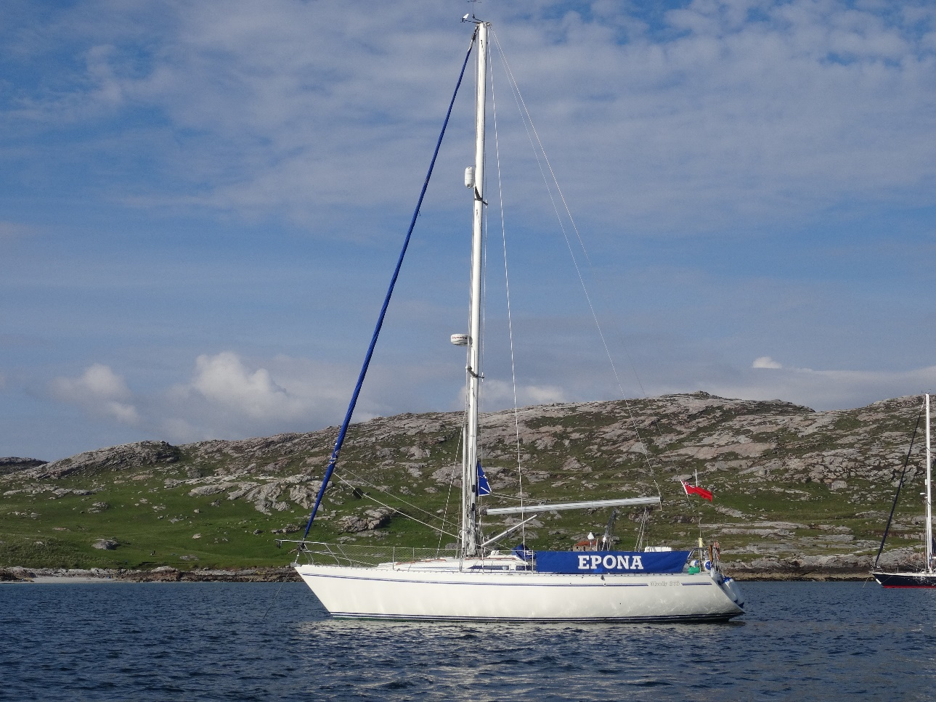
Taransay anchorage June 2022

