Honda 2.3 HP Outboard for Sale - £500 ono
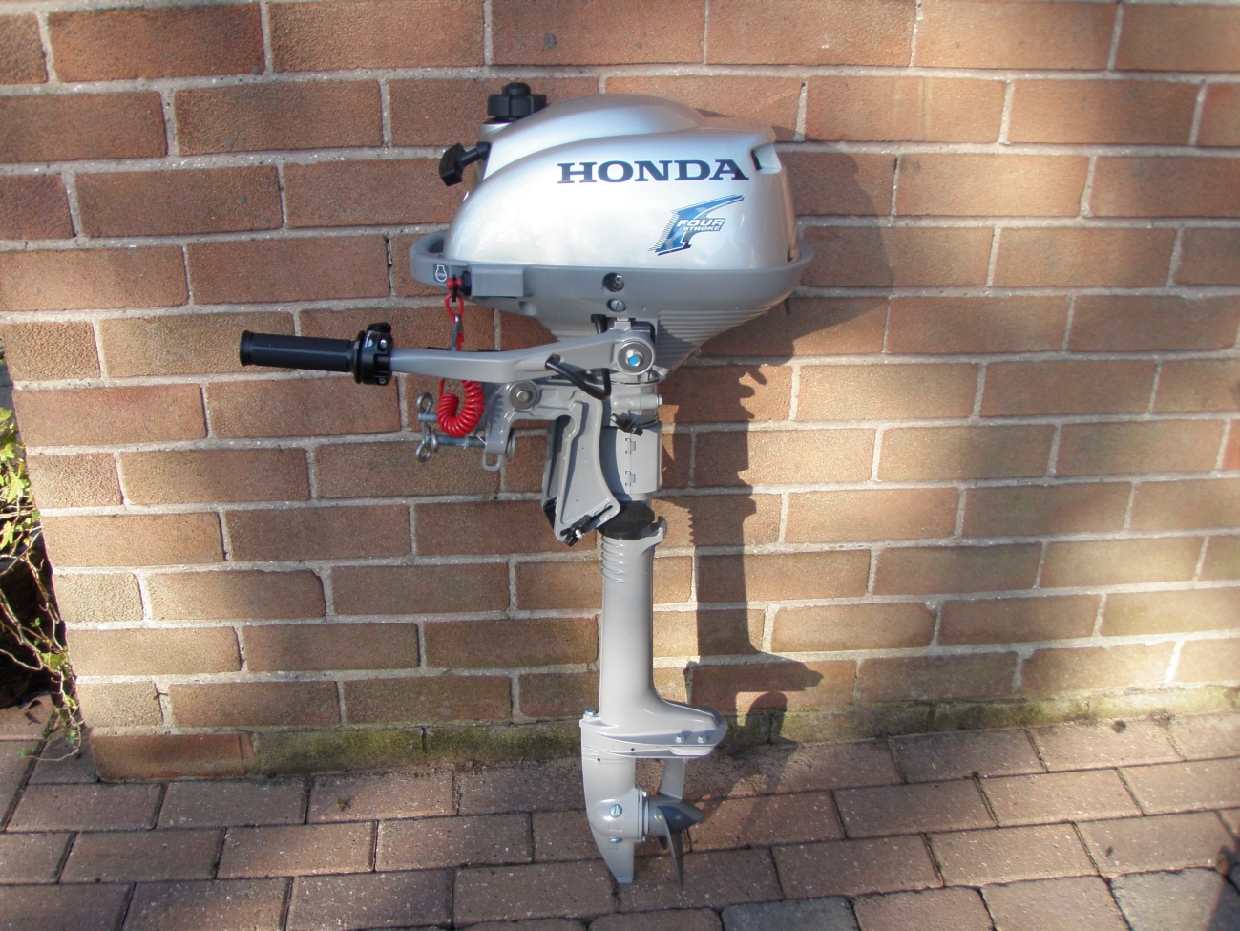
Bought new in 2019 and used for one season only.
air cooled, light weight compact,
auto clutch, 1lt built in fuel tank
large carrying handle
emergency kill switch
one handed operation
360deg engine rotation
twist grip throttle
easy to transport
Located Cheshire or could bring down to the Hamble or Conwy
For further details please contact Martin Atkinson
Tel : 07742 050217 email : Martin.N.Atkinson@BTopenworld.com

