Successfully changing keel studs, plates and nuts on a Moody 43 Eclipse.
We have all heard it from the experts. “Yeah, Moody’s always have water in the bilge and the studs and nuts get rusty but don’t worry they will be OK”. Maybe so but not when we are having to present “Spirit Chaser”, our 1992 Moody 43 Eclipse to a surveyor so that we can get a clean bill of health and renew our insurance.
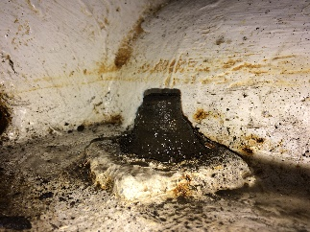
So like all of us I headed to the web and started reading. It seemed simple really. My mate Matt and I decided to replace the nuts while she was berthed in the marina at Magnetic Island, Queensland. The first step was to ignore the advice from the would-be comedians that we shouldn’t undo all the nuts at the one time. Instead we put our attention to the more technical aspects of the job - what was the stud diameter, what was the pitch and how would we remove the nuts.
After sponging every last drop of water pot of the bilge and chipping away the remnants of the flow coat, it was clear that determining the size would be the first problem because, as can be seen in the photos, the nuts and the studs were too corroded to measure. After a bit more research we determined that there were eleven M24 studs and five M30s. However, the amount of rust caused me to think that each stud and nut had morphed into a single unit so their removal was going to require some planning.
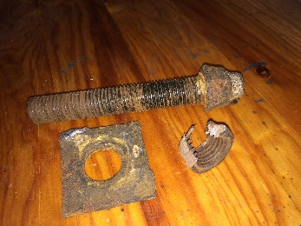
Last year I had sought some advice from a fellow Moody owner who resolved to replace the studs as well and had welded new nuts onto the studs on her boat to aid removal but I thought I would try a simpler approach before resorting to that complexity. She did say that replacing the stud turned out to be unnecessary as once the nut was removed it was clear that the studs were ok. This photo of one of my studs and a nut that had to be cut off does show the stud to be in good condition.
So at the end of last season, before leaving the boat, I cut the base out of some plastic cups and sealed them around each nut with silicon then filled each cup with Penetrene. I prayed that when I returned after four months, miracles would have happened and the nuts would unscrew with ease. I arrive back to the boat with new plates that I had laser cut and new nuts. Unfortunately during my absence, the float switch on my bilge pump decided to retire resulting in each cup being full with a mixture of Penetrene and the Coral Sea which had not assisted the project.
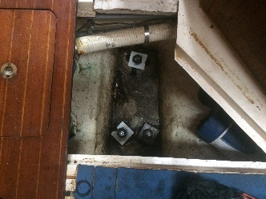
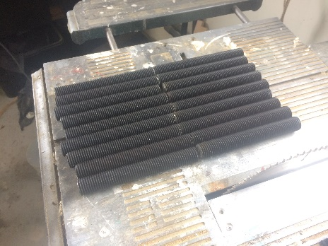
I decided to push on and simply force onto each nut whatever socket I could and use extension bars and a breaker bar accompanied by a sizable length of water pipe to provide some additional leverage but the result was zero. Tried another nut but still nothing moved. Suddenly fortune shine as the marina manager appeared with an 18 volt rattle gun. Saved I thought but even with the persistent torque of the rattle gun we still saw no movement. Then I recalled a comment on the Moody Forum about the holding power of the nut to the plate so I went back to chipping away at the seams. Finally we got movement but instead of removing the nut as planned, the stud unscrewed from the keel. Tried another nut with the same result so we decided that it would be easier to also replace the studs instead of trying to remove the nuts. Once the crud was chipped away, each stud came out easily thanks to the rattle gun.
I purchased four meters of M24 and two metres of M30 All-Thread which we cut to size. The 24mm studs are 180 mm long and the 30mm ones are 320mm. Thereafter the job seamed easy. We topped up the caulking thread with a bit of Sika, fitted the new plates and torqued up the nuts. Lat task is to apply primer and a number of coats of sealer to protest them for the future.

